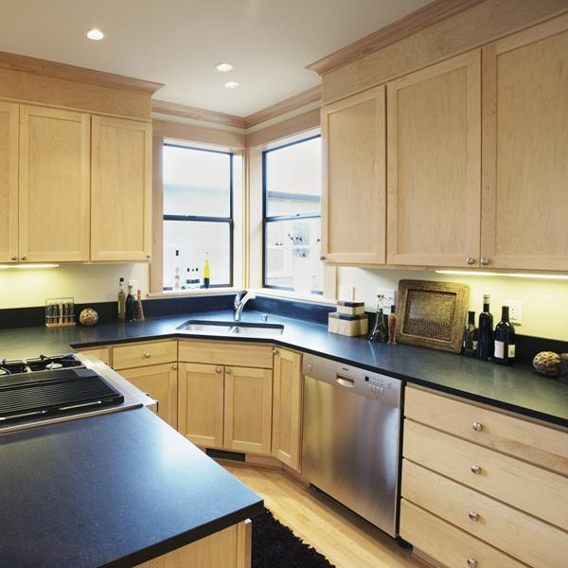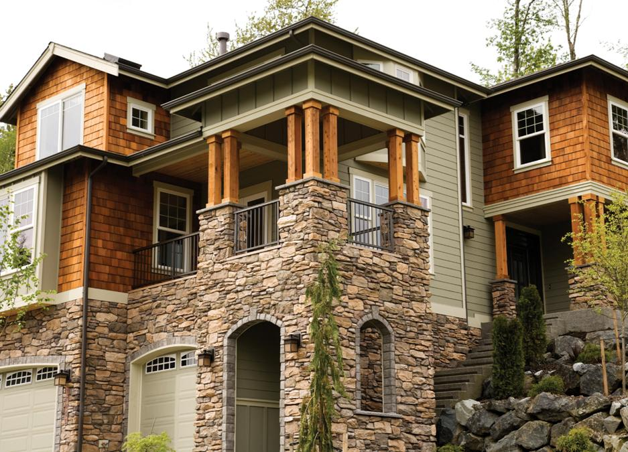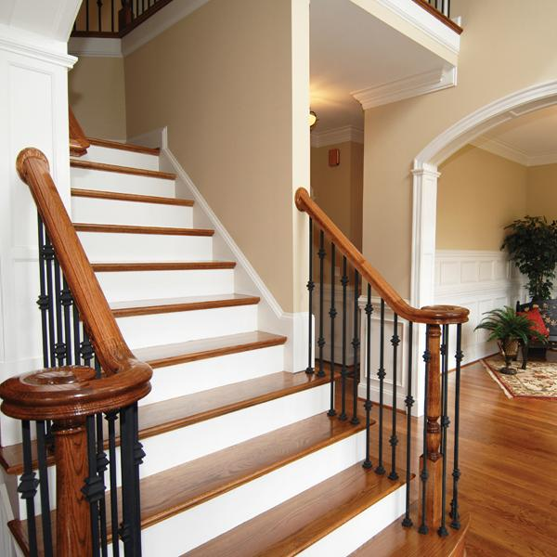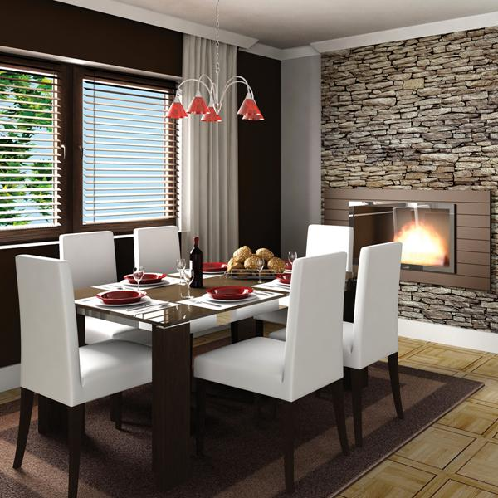On

**R & D Legacy Properties, LLC**

**Stage and Sell Properties Faster and More Profitably.**

**Staging Includes: Professional Consultation, Staging Plan, Professional showcasing of Home - Open House Ready. Post Sale: Furniture Rental pick-up, House emptied of all staging décor.**

*Please call to arrange a consultation* **Dawn Samuelson,** Certified Staging Professional @ CSP International

**206-498-3828 rdlegacyproperties@gmail.com**

R&D Legacy Properties, LLC

Sell More Profitably

Consultation Fee:

$175.00 Small Home

$250.00 Large Home

Showcasing:

Exterior, Kitchen & Dining, Master BDRM, 2BDRM, Family Room, 2Bathrooms - $550.00

Additianl BDRMS – $50.00

Additional Bathrooms – $25.00

Additional Living Rooms – $100.00

Offices – $50.00

Outdoor living Spaces - $100.00

***Staging***

***Fee***

***Schedule***

Sell Quickly

Sell Confidently

On Trend

Buyer Focused